TUTORIAL TO DOWNLOAD DATASETS FROM KAGGLE

* We must first open any web browser in order to download datasets from Kaggle.



* Go to the search bar then type Kaggle.com or click on the below link to get Kaggle official website (<https://www.kaggle.com/>).
* Click the link and enter your login information.
* 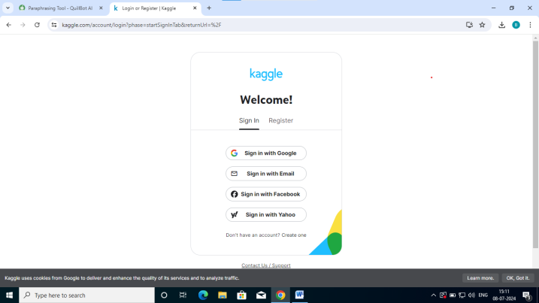
* In Kaggle, use the search bar to download your datasets, then open them.

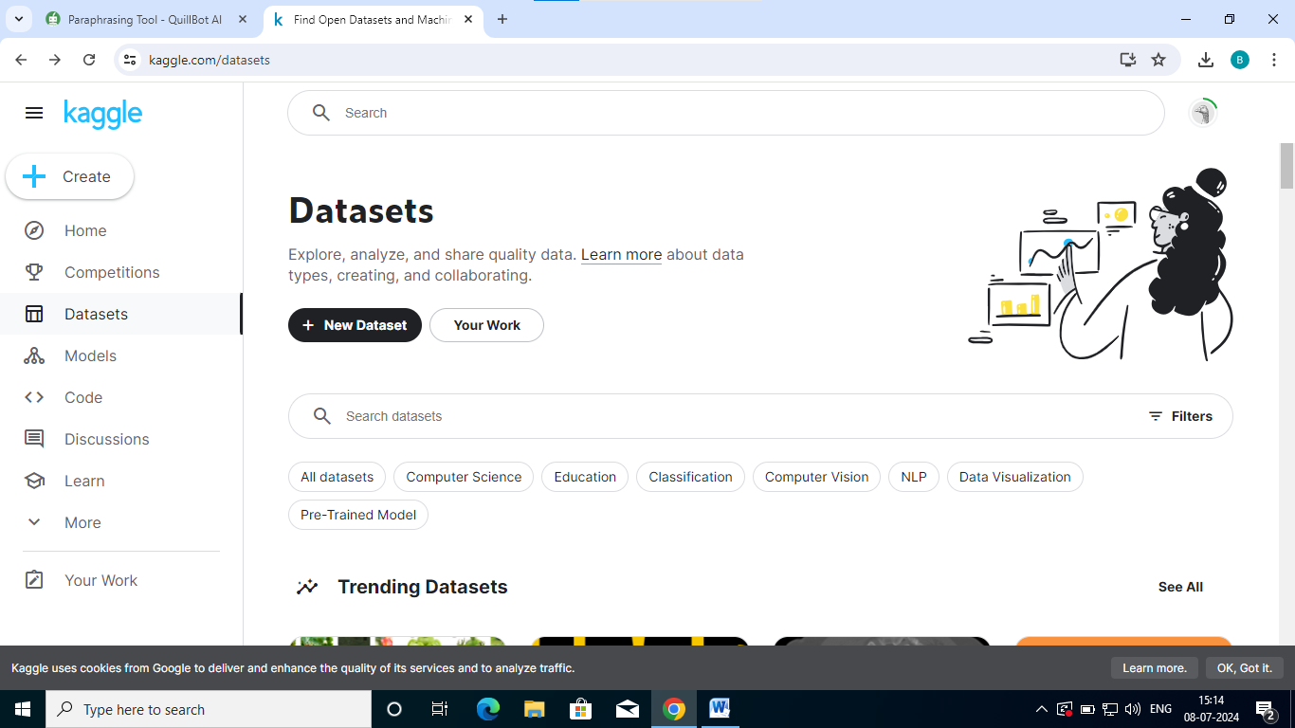

**PERFORMING EXPLORATORY DATA ANALYSIS :**

# What is Exploratory Data Analysis ?

# *Exploratory Data Analysis (EDA) is a process in statistics and data science used to analyze and summarize the main characteristics of a dataset, often with visual methods.

# STEPS INVOLVED IN EDA:

# Understand the problem and data.

# Import and inspect data.

# Handle missing values.

# Explore data characteristics.

# Perform data transformation.

# *Performing Exploratory Data Analysis (EDA) of the given Data Set.

# Understand the problem and data:

# At first we have to understand the problem and data then we have to move to another step.

# Import and inspect Data:

# Import your data set to your environment.

# Handle missing values:

# There are several useful functions for detecting, removing, and replacing null values in Pandas DataFrame

# METHODS

# .isnull()

# Identifies missing values in a Series or DataFrame.

# 

# .notnull()

# check for missing values in a pandas Series or Data Frame. It returns a boolean Series or Data Frame, where True indicates non-missing values and False indicates missing values.

# .info()

# Displays information about the Data Frame, including data types, memory usage, and presence of missing values.

# .isna()

# similar to notnull() but returns True for missing values and False for non-missing values.

# PROGRAM:

# import numpy as np

# import pandas as pd

# data=pd.read_csv("Sportcarprice.csv")

# print(data)

# print(data.head())

# # The head() function in pandas displays the top rows of a DataFrame.

# 

# 

# 

# Print(data.tail())

# # The tail() function in pandas displays the top rows of a DataFrame.

# 

# ##performing statistical operations on data set

# import numpy as np

# import pandas as pd

# data=pd.read_csv("Sportcarprice.csv")

# #print(data)

# print(data.describe())

# 